Balisacan, Mark Justin F. BSIT 4-1 WMAD
Binuya, John Lloyd A.
Reyes, Allysa B.

WEEK 1: Project Review and Development Planning

INTENDED LEARNING OUTCOME
At the end of this activity, students should be able to:
Develop a comprehensive project implementation plan by reviewing the approved capstone proposal, validating project scope, incorporating panel recommendations, assigning project responsibilities, preparing a project schedule, and establishing project monitoring tools.

OVERVIEW OF WEEK 1 OUTPUTS
By the end of Week 1, each group must submit:
- Panel Recommendation Compliance Matrix
- Project Scope Validation Form
- Work Breakdown Structure (WBS)
- Revised Gantt Chart
- Project Development Plan
- Repository Setup Report
- Adviser Consultation Record

ACTIVITY 1
Review of Panel Recommendations

Purpose
To ensure that all recommendations from the proposal defense have been reviewed and addressed before implementation begins.

Procedure
- Secure a copy of the proposal defense evaluation sheet.
- Review all comments from the panel.
- Discuss as a group how each recommendation will be addressed.
- Complete Form 1.

FORM 1
PANEL RECOMMENDATION COMPLIANCE MATRIX

Instructions
For every recommendation:
- Copy the recommendation exactly as stated by the panel.
- Describe the action that the group will take.
- Identify supporting evidence.
- Mark the status.

No. | Panel Recommendation | Planned Action | Evidence | Status
1 | Remove the terms web and mobile, real time, and crowdsource in the project title. | Revise the project title. | Updated the project title. | Completed
2 | Describe how the agency currently handles the situation. | Revised the Background of the Project by including a clear description of the agency’s current manual processes in handling outage reports. | Updated the Background of the Project | Completed
3 | Include in the objective the user acceptance, size it is reflected in the RRL.  Include objective for evaluation of SUS. | Revised the objectives by adding evaluation components. | Revised research objectives and evaluation section with SUS included. | Completed
4 | Discuss the user roles properly. | Revised by clearly explaining the user roles and their functions in the system. | Updated system user roles and responsibilities in Scope of the Study. | Completed
5 | Replace or remove the term “non tech savy”. | Removed the term “non tech savy” | Revised manuscript with the term removed and replaced by appropriate wording. | Completed
6 | Add RRL related to objective and itemize based on your objective. | Revised the RRL by aligning related literature with the study objectives. | Updated Review of Related Literature organized according to each research objective. | Completed
7 | Include a comparison between My Naga and ISELCONNECT. | Revised the Chapter 2 by adding a comparison between My Naga and ISELCONNECT and explaining their differences. | Added comparison table and discussion between My Naga and ISELCONNECT in Chapter 2. | Completed
8 | Use SMS OTP instead of email verification code | Upon creating account, users are required to upload a photo of their valid ID for verification and use email for OTP since email now require one number one email. | Updated account registration and verification workflow with valid ID submission and email OTP authentication. | Pending
9 | Add a validation to avoid false report. | Use live photo instead of upload image. | Implemented live camera capture requirement for report submission to improve report authenticity. | Pending
10 | Notifications should be limited to only the affected or specific area, instead of being sent to all consumers. | Implement a location-based notification system that sends alerts only to consumers within the affected barangay or service area. | Updated notification workflow to support area-based notification filtering. | Pending

ACTIVITY 2
Project Scope Validation

Purpose
To verify that the approved project remains feasible and aligned with client requirements.
Procedure
- Review Chapter 1 and Chapter 3.
- Verify all objectives.
- Review scope and limitations.
- Identify any requested modifications.
- Complete Form 2.

FORM 2
PROJECT SCOPE VALIDATION FORM

Instructions
Check whether each component remains valid.

A. Objectives Validation
Objective | Still Applicable? | Remarks
Design, develop, and implement ISELCONNECT to streamline and improve power interruption and maintenance reporting and dissemination for ISELCO-1. | Yes | Validated by the primary project scope and core purpose of the ISELCONNECT platform.
Design and develop dedicated modules for Administrators, Linemen, and Residents to handle real-time logs, accounts, analytics, task updates, mapping, and geotagged damage reporting. | Yes | Validated by the specific feature requirements established for all three user types within the application.
Evaluate system compliance against all eight ISO/IEC 25010 system quality evaluation metrics. | Yes | Validated by the planned quality assurance and evaluation framework for the software.

B. Requirements Validation
Requirement | Validated | Remarks
Functional Requirements | ☑ | Reviewed and verified based on the approved project scope.
Non-Functional Requirements | ☑ | Reviewed and verified based on the system specifications.
User Requirements | ☑ | Reviewed and verified based on the documented user needs in Chapter 1.
Hardware Requirements | ☑ | Reviewed and verified based on the identified deployment requirements.
Software Requirements | ☑ | Reviewed and verified based on the selected development technologies.

C. Scope Changes
List proposed modifications.
Proposed Change | Reason | Adviser Approval

ACTIVITY 3
Work Breakdown Structure Development

Purpose
To organize all project activities and distribute responsibilities among team members.

Procedure
- List all tasks needed to complete the project.
- Group similar tasks together.
- Assign responsible members.
- Estimate completion dates.
- Complete Form 3.

FORM 3
WORK BREAKDOWN STRUCTURE (WBS)

Instructions
Break down project activities into smaller work packages.

Major Deliverable | Task | Assigned Member | Due Week
Front-End Development | Login Interface | Mark Justin F. Balisacan  John Lloyd A. Binuya | Week 4
Back-End Development | Authentication Module | Mark Justin F. Balisacan  John Lloyd A. Binuya | Week 4
Database Development | Database Creation | Mark Justin F. Balisacan  John Lloyd A. Binuya | Week 1
Testing | Unit Testing | Mark Justin F. Balisacan  John Lloyd A. Binuya  Allysa B. Reyes | Week 8
Deployment | Installation | Mark Justin F. Balisacan  John Lloyd A. Binuya  Allysa B. Reyes | Week 10
Documentation | User Manual | Allysa B. Reyes | Week 14

Team Verification
All members must sign below:

ACTIVITY 4
Gantt Chart Preparation

Purpose
To establish a semester-long implementation schedule.

Procedure
- Use the completed WBS.
- Identify project milestones.
- Assign target weeks.
- Prepare the schedule.
- Complete Form 4.

FORM 4
GANTT CHART SUBMISSION FORM

Instructions
Indicate when each task will be performed.

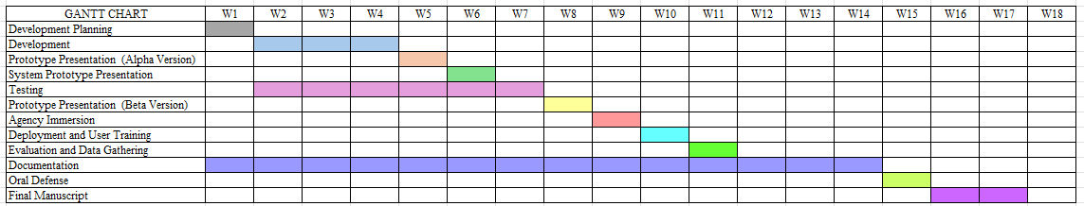

Milestone Schedule
Milestone | Target Week
Alpha Version | Week 4
Prototype Presentation | Week 5 - 6
Beta Version | Week 8
Agency Immersion | Week 9
Deployment | Week 10
Evaluation | Week 11
Mock Defense | Week 14
Final Defense | Week 15

ACTIVITY 5
Development Planning

Purpose
To prepare the overall implementation strategy.
Procedure
- Determine development methodology.
- Identify technologies.
- Assign project roles.
- Identify risks.
- Complete Form 5.

FORM 5
PROJECT DEVELOPMENT PLAN

A. Team Roles
Team Member | Role | Responsibilities
Mark Justin F. Balisacan | Web and Backend Developer | Develop the web system, backend, and database integration.
John Lloyd A. Binuya | Mobile and Backend Developer | Develop the mobile application and backend features.
Allysa B. Reyes | Quality Assurance | Test the system and ensure quality compliance.

B. Development Methodology
□ Agile
□ Scrum
□ Waterfall
□ Incremental
☑ RAD

C. Development Tools
Category | Tool
Programming Language | Javascript
Framework | Vue, React
Database | Supabase
IDE | Visual Studio, Android Studio
Repository | Github

D. Risk Management Plan

Risk | Probability | Impact | Mitigation
Internet connectivity issues | Medium | High | Provide offline data capture and sync when connected.
Delays in development | Medium | High | Follow a project schedule and monitor progress regularly.
System bugs and errors | High | Medium | Conduct regular testing and debugging.
Data security breaches | Low | High | Implement authentication, encryption, and access control.
Low user participation | Medium | Medium | Provide user orientation and an intuitive interface.
Hardware or device failure | Low | High | Perform regular backups and use reliable equipment.

E. Communication Plan
Activity | Schedule
Team Meeting | Every Saturday, 5pm
Adviser Consultation | As needed based on the adviser’s consultation schedule
Client Coordination | As needed

ACTIVITY 6
Repository Setup

Purpose
To establish version control and project collaboration mechanisms.
Procedure
- Create repository.
- Create project folder structure.
- Add all members.
- Commit initial files.
- Complete Form 6.

FORM 6
REPOSITORY SETUP REPORT

Repository Information
Repository Name:
ISELCONNECT

Repository URL:
https://github.com/ISELCONNECT-ORG

Member Access
Member | Access Granted
Mark Justin F. Balisacan | Yes
John Lloyd A. Binuya | Yes
Allysa B. Reyes | Yes

Required Screenshots
Attach:
□ Repository Homepage
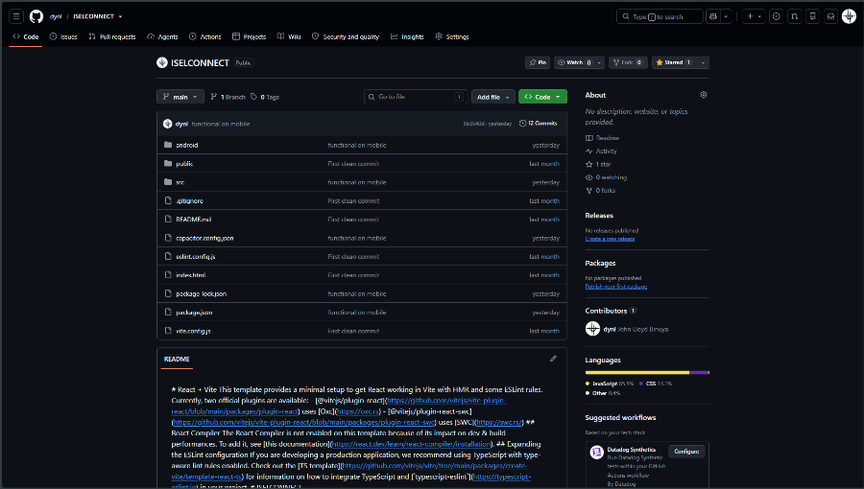

□ Team Members
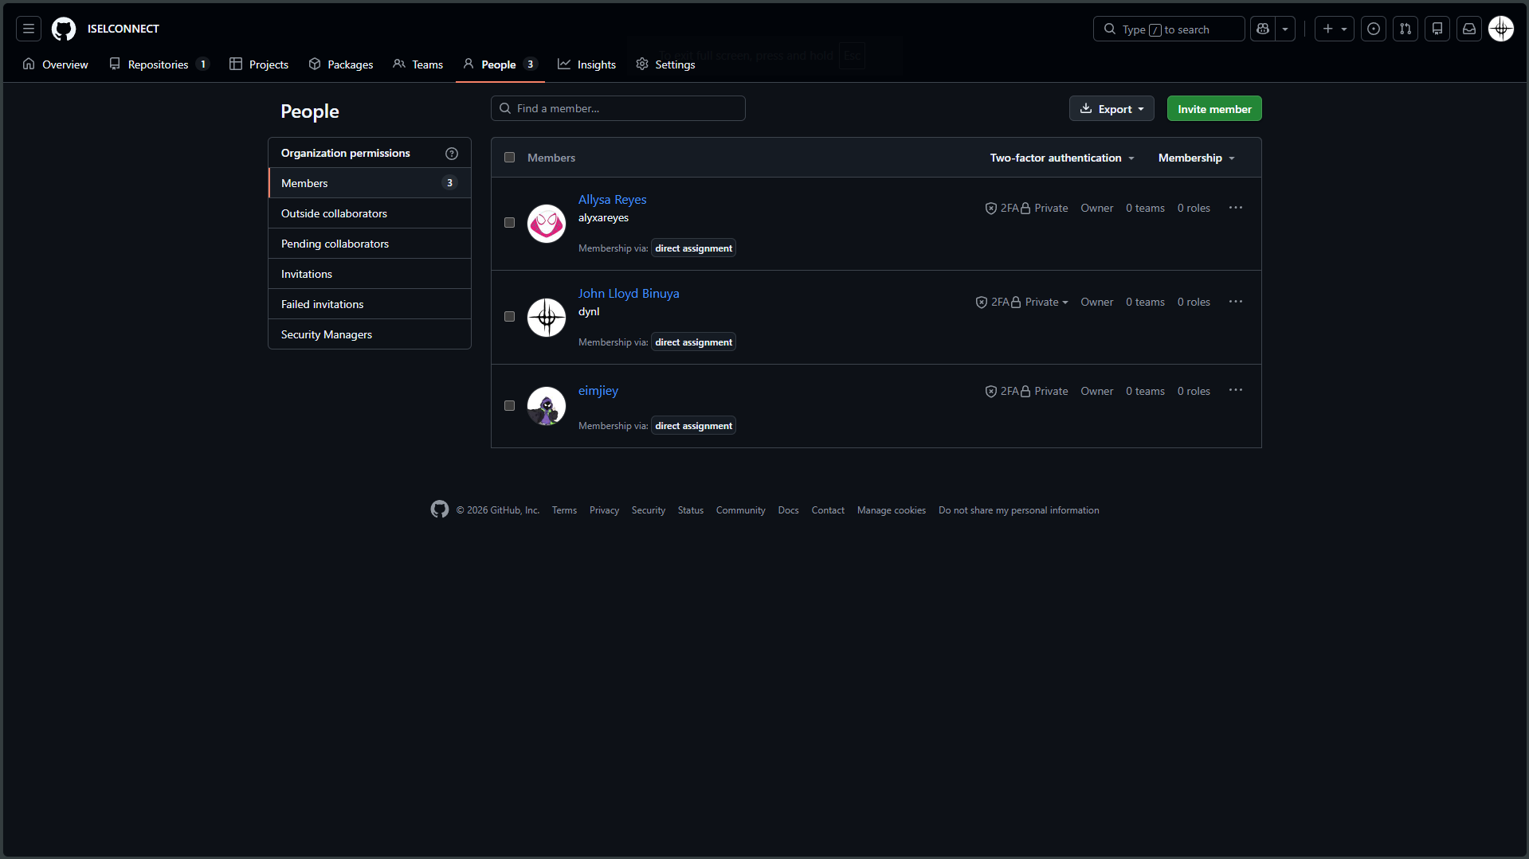

□ Folder Structure
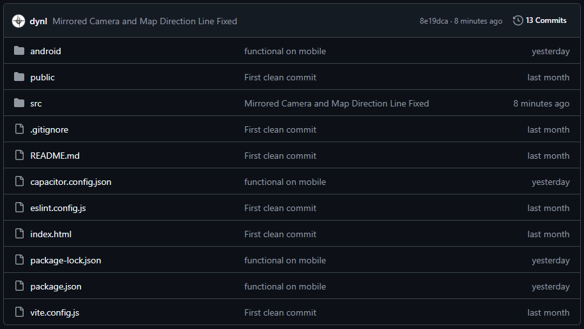
□ Initial Commit
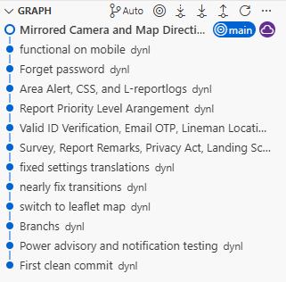

Repository Information
Repository Name:
ISELCONNECT

Repository URL:
https://github.com/ISELCONNECT-ORG

Member Access
Member | Access Granted
Mark Justin F. Balisacan | Yes
John Lloyd A. Binuya | Yes
Allysa B. Reyes | Yes

Required Screenshots
Attach:
□ Repository Homepage
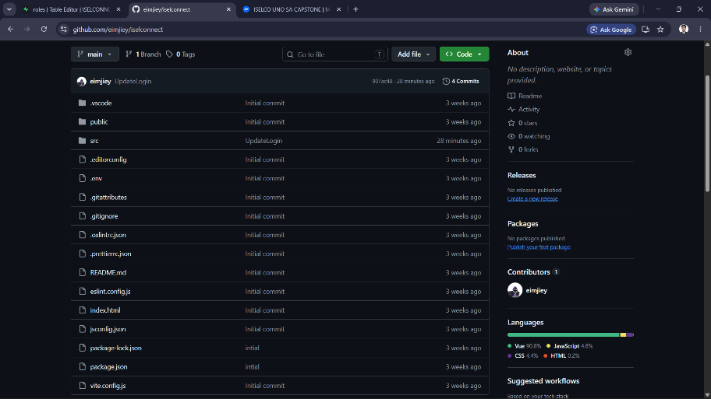

□ Team Members

□ Folder Structure
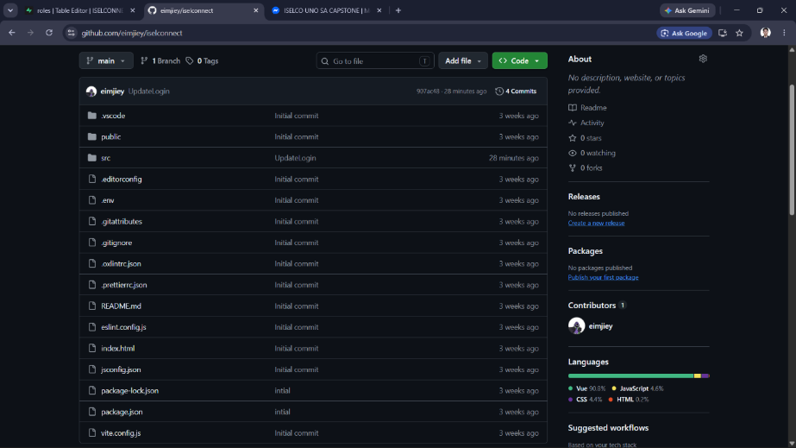
□ Initial Commit
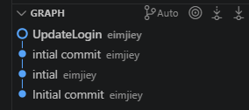

Repository Structure
List folders created.
Folder Name | Purpose
/docs | Documentation
/database | Database Scripts
/frontend | Interface Development
/backend | Server-side Development

